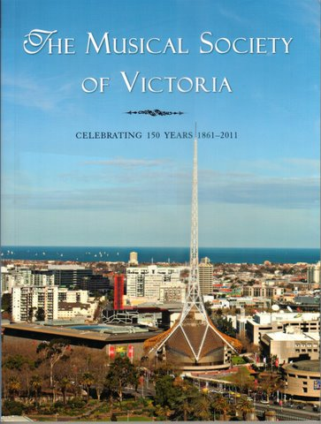

HISTORY BOOK – ORDER FORM

The Musical Society of Victoria
Celebrating 150 Years 1861-2011
ISBN: 9781921756863

Written by Eril Tan, long term MSV member,
this book celebrates MSVs achievements and commitment to the encouragement and enjoyment of music. The book presents over 100 pages describing the remarkable history of MSV, showing the development of musical culture in Victoria across changing social times.

Name ________________________________________

Address ________________________________________

________________________________________ Post Code _____

Telephone __________________

NUMBER OF BOOKS @ $10 each: $__________________

POSTAGE AND HANDLING: $ 5.00

TOTAL AMOUNT ENCLOSED: $_________________

PAYMENT METHOD: ___ cheque / money order (made payable to Musical Society of Victoria)
___ credit card (see below)

** GST free under ATO items NAT 3346 & 7966.

Master Card __ Visa Card __ Card No:________________________________ Expiry Date _____/_____

Name on Card_____________________________ Signature ______________________________________

Please return Order Form to:
The Hon. General Secretary, MSV, P.O. Box 2234 Wattletree Road P.O. VIC. 3145

MSV ABN: 99 004 252 288 www. msv.org.au Tel: 9509 7767

